# GAN

Some classical GAN.

1.CycleGAN

Cycligan is often used for style transfer in the field of cv, such as converting real images into Monet's style, converting zebras into wild horses, and converting summer into winter, as shown in the figure.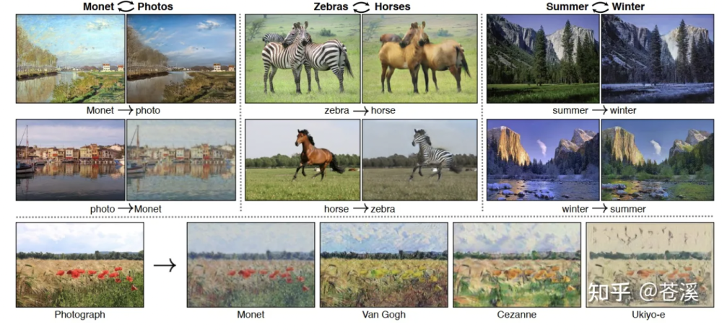

2.DCGAN

DCGAN is a direct extension of GAN, with the difference that it explicitly uses convolutional and convolutional transpose layers in the discriminator and generator, respectively. Traditional gan can only generate some simple images, but the emergence of DCGAN allows GAN to generate some complex content.

Fake Images generated by DCGAN are shown in the figure.

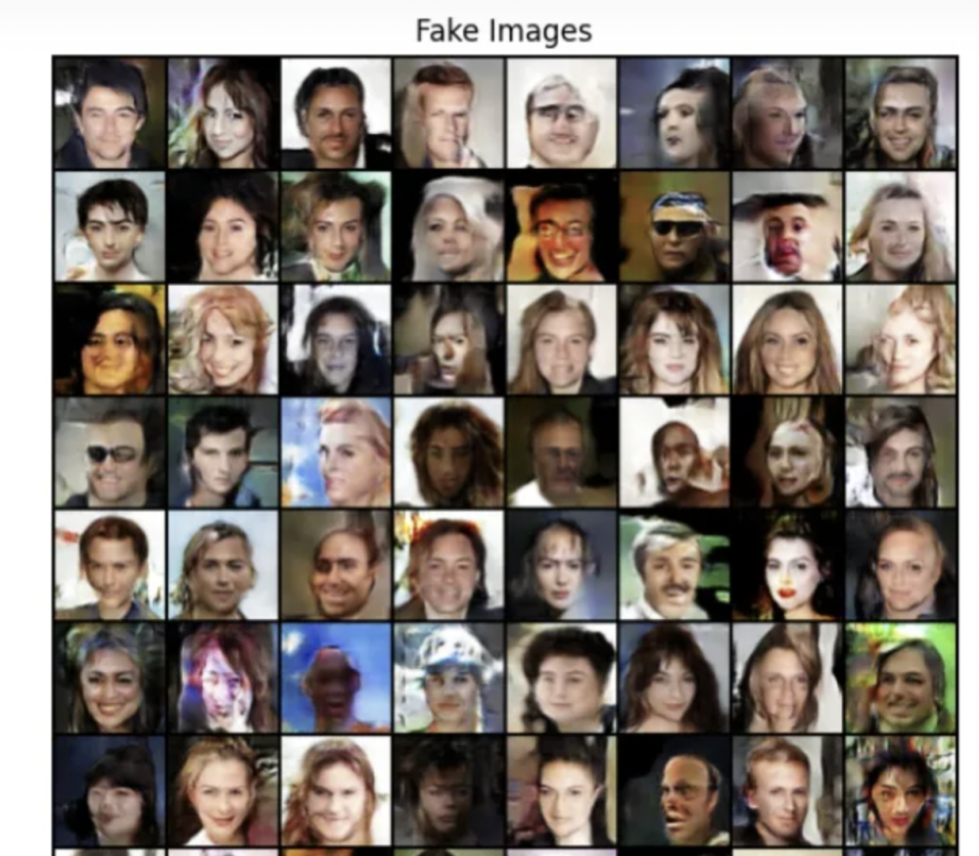

3.CGAN

"CGAN" means conditional GAN. CGAN can make the results generated by GAN meet certain conditions, that is, it can manually change the input vector to control the final output result.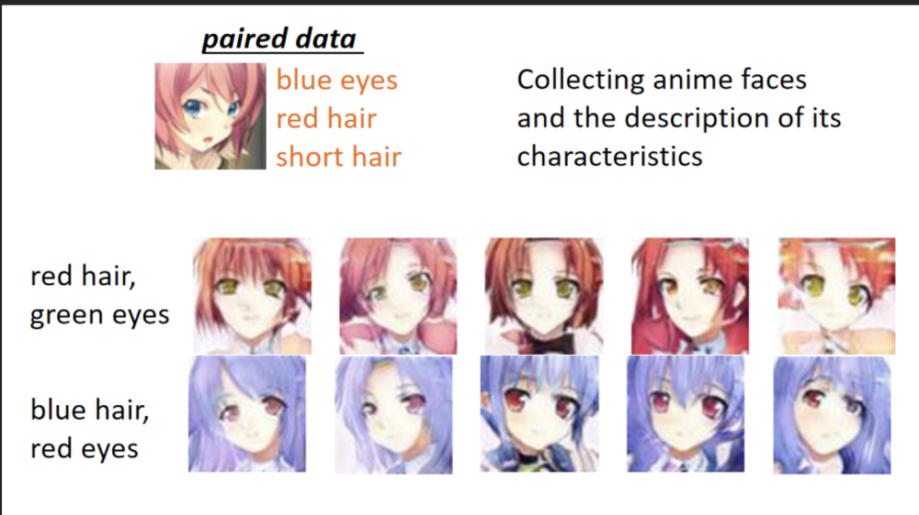

GAN

The main structure of GAN includes a generator G and a discriminator D. The generator will use random noise to fit the true distribution and train it with the true distribution in the discriminator until the discriminator cannot distinguish whether the image comes from the true distribution or the generator fitted distribution.

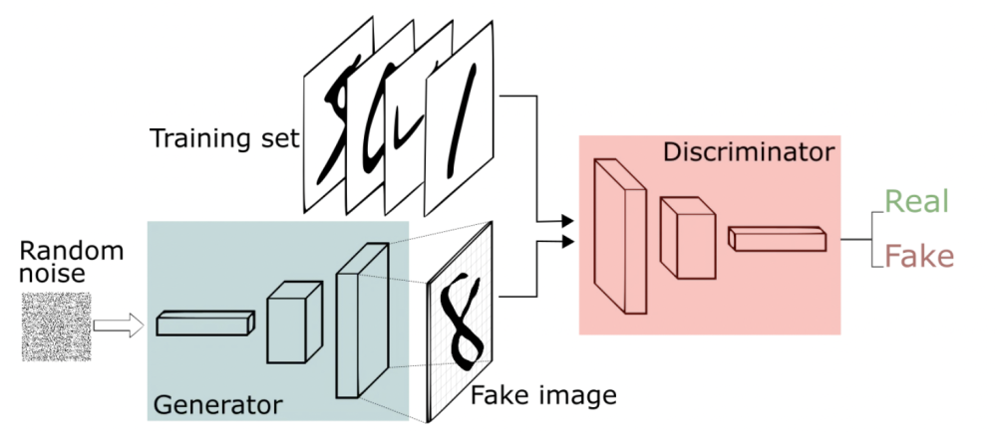

Objective function:



* The formula consists of two terms: x represents the true distribution, z represents the noise of the input G network, and G (z) represents the content generated by the G network.
* D (x) represents the probability that the D network will determine whether the true distribution is true or not. x comes from the true distribution, so for D, the closer this value is to one, the better it is.
* D (G (z)) is the probability that the D network determines whether the image generated by G is true or not.
* Purpose of G: G should hope that the images generated by itself are as close to reality as possible.

Purpose of D: The stronger ability of D is, the greater D (x) should be, and the smaller D (G (x)) should be. At this time, V (D, G) will become larger, so the formula is to seek the maximum.

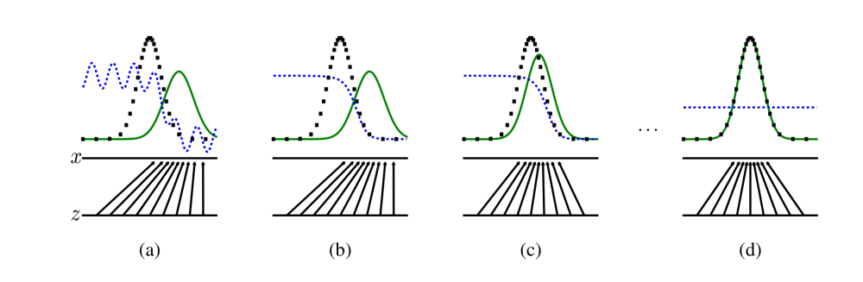

The black dotted lines in the figure represent the distribution of real samples, the blue dotted lines represent the distribution of discriminator discrimination probability, and the green solid lines represent the distribution of generated samples. Z represents noise, and Z to x represents the mapping of the distribution after passing through the generator.

(a)As the initial state, the distribution generated by the generator is significantly different from the real distribution, and the discriminator has also experienced oscillations. Therefore, the discriminator will be trained first to better distinguish samples. After multiple training, the discriminator reaches the (b) state, where the discriminant samples are distinguished significantly and well. Then train the generator. After training the generator, it reaches the state of (c), where the generator distribution approximates the true sample distribution compared to the previous one. After multiple iterations, the final state of (d) can be reached. The generated sample distribution fits the true sample distribution, and the discriminator cannot distinguish whether the sample is generated or true. The accuracy rate of the discriminator is now 0.5.

Disadvancement: It is very difficult to fit and prone to mode crashes